I assume, this will be first thing that the customer sees once they’ve scanned the QR code at the festival OR they’ve followed the link from the website/Instagram.
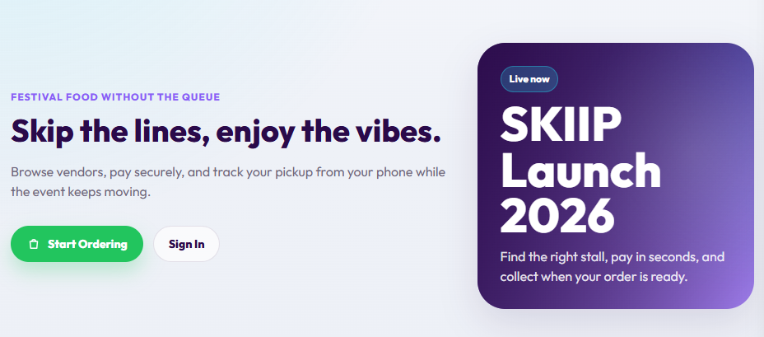

- Change typography:
- Festival food without the queue Food without the queue
- Browse vendors, pay securely, and track your pickup from your phone while the event keeps moving. Browse → Pay → Collect OR
Order from your phone.
Get notified when it’s ready.
Use “Browse → Pay → Collect” as option one. But if you can’t get the arrows in, use “order from your phone…”

- Functionality:
Let’s remove the “Sign In” button because it currently stays there even if someone is signed in. And on coming into the webapp, it already says sign in in the banner. So let’s just remove it and keep “Start Ordering”.


I am not sure what we are planning to do with the purple box.
I like the “Live now”. Let’s keep that.
What we should say in the box:
- Name of the event (launch will be: SAWFT)
- Official event ordering
- Your food doesn’t need a queue anymore.

- At the bottom of the website
Using Deliveroo as inspo, we need a section at the bottom that has a link to:
- Who we are (takes a person to the static website)
- Cookies
- Privacy
- Terms and Conditions
- Help

ONCE A PERSON HAS CLICKED “START ORDERING”

- Vendor search

Change “Choose your stall” What do you fancy?

For drinks, we should have:
BROWSE THE BAR
Now pouring

- List of vendors
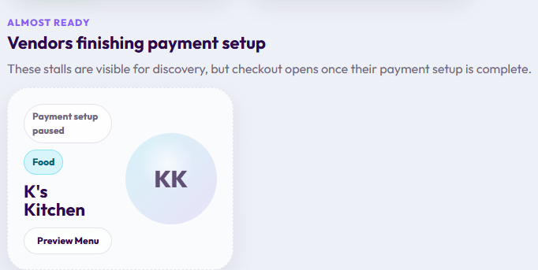
The customer should not see this please. Either we have live vendors, or we don’t.

- Checkout
On the phone, when you select items to check out, it isn’t clear that they are on the cart in the same way you can see it on the web. Can we fix that? Like have a tally of items on the cart emoji?
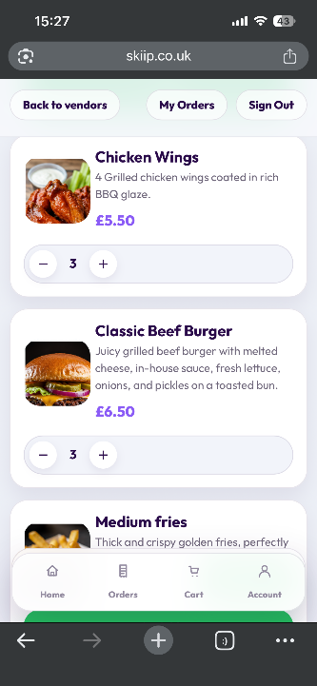
- Notifications
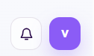
I noted the notification button. Will customers receive notifications on the webapp?

- Logo

Please don’t forget to change the logo to the actual logo.

VENDOR PORTAL
- Please put a filter of all types of orders – “needs review”, “new”, “preparing” and “ready”. Without a filter, it looks a bit cluttered when viewed on the mobile.
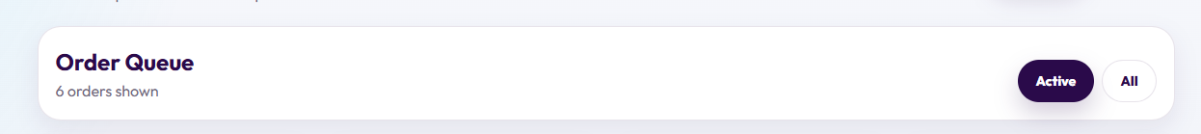

- When I click “Profile”, this pops up.
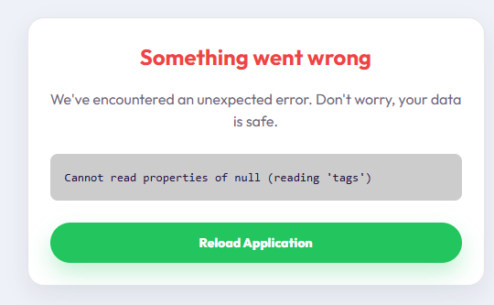

- How do we enter the admin page?

